9.1.5 Editors - UV Editor - Header - UV menu.odt
UV menu 2
Transform 2
Mirror 3
Snap 4
Unwrap ABF 4
Unwrap Conformal 4
Follow Active Quads 5
Pin 5
Unpin 6
Merge 6
Split 7
Pack Islands 7
Average Island Scale 7
Minimize Stretch 8
Stitch 8
Mark Seam 9
Seams from Islands 10
Align 10
UV Select Mode 11
Show / Hide Faces 11
Reset 12
Export UV Layout 12

UV menu
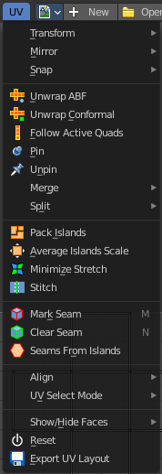

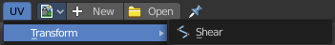
Transform

Shear
Shear shears the selection.

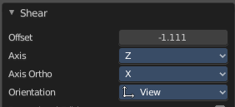
Last Operator Shear

Offset
Adjustan offset.

Axis
Defines one axis of the imaginary shear axis plane.


Axis Ortho
Defines the other axis of the imaginary shear axis plane.

Orientation
Choose the orientation for the shear action.

Proportional editing

Enables proportional editing. Activating proportional editing reveals further settings.

Proportional Falloff
Adjustthe falloff methods.

Proportional Size
See and adjust the falloff radius.

Connected
The proportional falloff gets calculated for connected parts only.

Projected(2D)
The proportional falloff gets calculated in the screen space. Depth doesn't play a role. When it's in the radius, then it gets calculated.

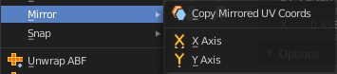
Mirror

Copy Mirrored UV coords
Copies and pastes the selected UV geometry on the X axis based on a mirrored mesh.
Use UV Select Sync must be off. The tool does not work with Use UV Select Sync on. And it is not fully reliable as our example shows.

X
Mirrors the selection in X axis. The mirror point is the pivot of the selection.

Y
Mirrors the selection in Y axis. The mirror point is the pivot of the selection.

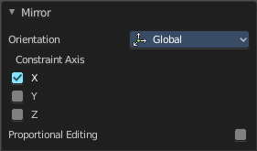
Last Operator Mirror
The Last Operator Mirror panel gives you tools to adjust the mirror action.

Orientation
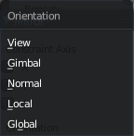
Orientation is a drop-down box wChoose the type of orientation for the mirroring action.

Constraint Axis
Constraint Axis gives you the possibility to define the mirror axis. You can choose more than one axis here.

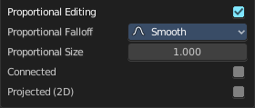
Proportional Editing
Activates proportional editing.

Proportional Editing Falloff
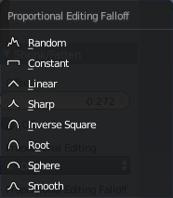
Proportional Editing Falloff is a drop-down box wChoose a method for the falloff for the proportional editing.

Connected
The proportional falloff gets calculated for connected parts only.

Projected(2D)
The proportional falloff gets calculated in the screen space. Depth doesn't play a role. When it's in the radius, then it gets calculated.

Snap
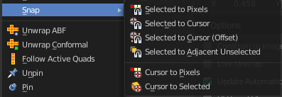
Snap is a sub menu with some snapping tools. The menu items should be pretty self explaining. Selected to Pixels snaps the selected geometry to the pixels of the image, and so on.

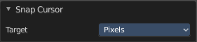
Last Operator Snap Selection and Snap Cursor

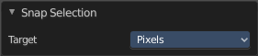
Target
Set the snap target method again.

Unwrap ABF
Unwrap ABF unwraps the selected geometry with the method Angle based. ABF stands for Angle Based Flattening. ABF can give a bit better result than LSCM when unwrapping organic shapes.
Note that you need to have the geometry selected in the 3D view.

Unwrap Conformal
Unwrap ABF unwraps the selected geometry with the method Angle based. ABF stands for Angle Based Flattening. Conformal, also called LSCM, can give a bit better results than ABF with geometric shapes.
Note that you need to have the geometry selected in the 3D view.

Last Operator Unwrap
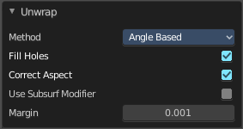
The last operator appears in the 3D view. Unwrap ABF and Unwrap LSCM shares the same Last Operator.

Method
Method is a drop down box wChoose between Unwrap method Angle Based and Conformal.

Fill Holes
Fill holes in the mesh before unwrapping.

Correct Aspect
Take the Image Aspect Ratio into account.

Use Subsurf Modifier
Unwraps an existing Subsurf Modifier. You need to add a Subsurf Modifier first.

Margin
The distance between the single UV patches.

Follow Active Quads
Follow Active quads maps UV coordinates starting from an active face, and maps all adjacent faces in quad shape then. This way you can for example unwrap a pipe or a road. You first need to have a face selected. Then select everything. And then click at Follow Active Quads.

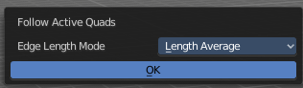
Settings

Edge Length Mode
Edge Length Mode is a drop-down box where you can choose the Length method.

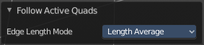
Last Operator Follow Active Quads
The Last Operator contains the same settings than the Settings dialogue.
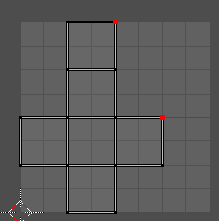

Pin
Pins the selected vertices . This vertices are now nailed for the unwrap algorithms Angle based and Conformal. Their positions will not change when you repeat the unrwapping. And the algorithms will try to fit the rest of the geometry to this pinned vertices.
Pinned vertices are marked red.
A use case is for example when you have a distorted result for symmetric geometry like a face with the Conformal method. Then you can try to align two center vertices, pin them, and repeat the conformal method. It may be more symmetrical afterwards.

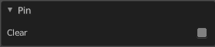
Unpin
Unpins pinned geometry.

Last operator Pin
This last opeartor appears in the 3D view. Pin and unpin shares the same last operator.

Clear
Unpins pinned geometry.

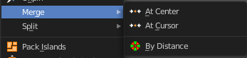
Merge

At Center
Merges the selected vertices at the centerpoint.

At Cursor
Merges the selected vertices not only at the cursor. The last operator provides you with four methods.

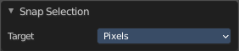
Last Operator Snap Selection

Target
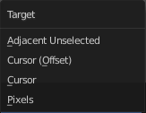
The snapping target. Snap and merge at the following locations.
Adjacent unselected
Cursor ( Offset)
Cursor
Pixels

By Distance
Merge UV vertices when they are below a merge distance.

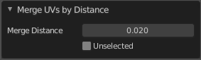
Last Operator Merge UV's by Distance

Merge Distance
The merge distance below the vertices gets merged.
Unselected
Merge selected vertices to unselected vertices.

Split
Splits the selected geometry. UV Sync Selection needs to be off.

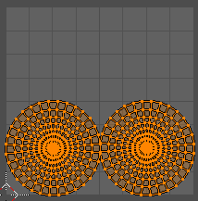
Pack Islands
Pack Islands tries to pack the selected UV geometry as close together as possible. Without to waste too much empty space.
Note that the algorithm fails at round geometry. It calculates with rectangle shapes.

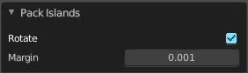
Last Operator Pack Islands
This last opeartor appears in the 3D view.

Rotate
Allow the UV patches to be rotated while the pack operation.

Margin
UV patches needs a margin between the single patches. So that the pixels of the texture doesn't bleed into other areas. Adjustthis margin.

Average Island Scale
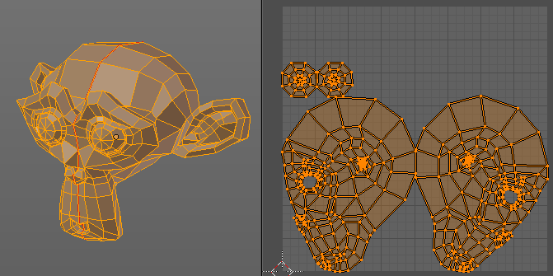
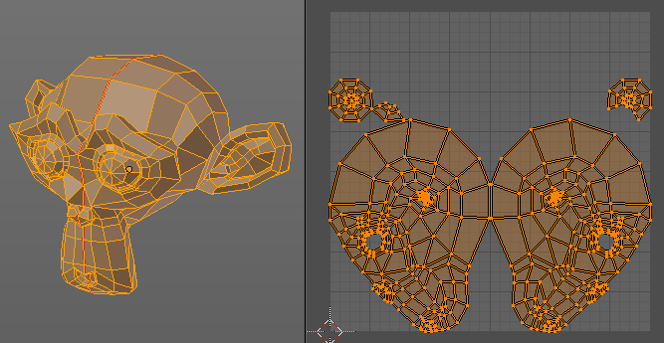
Scales the selected UV geometry to have the same relative size than the rest of the mesh. So that the texels at the mesh have roughly the same size everywhere.

Minimize Stretch
You might end in a UV mapping result that still shows unwanted distortions here and there. For example when you uv map a human face. Minimize Stretch tries to minimize this stretching effects in the UV patches.
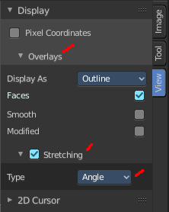
To view stretched areas at your UV patches, tick Stretch in the Properties Sidebar in the Display panel, and switch from Angle to Area. Then a stretch mask gets displayed. The color range goes from blue to green to red, where blue is minimal stretch and red is maximal stretch.

Let's explain it with an example. A sphere where the cut is nearly at the pole. And uv mapped with Angle Based. The result will of course show heavy stretched areas.
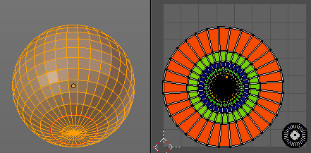

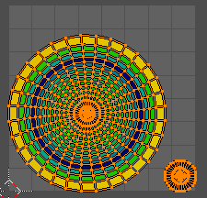

Note that the UV geometry must be selected in the UV Image editor. Now let's use the Minimize stretch tool. The algorithm now first tries its best to find the best fitting result that shows fewest stretching across the overall UV geometry.

The header shows a help text while the algorithm works. The Blend factor is the value between the original unwrapped UV mesh, and the maximum minimized stretch. You can set this value manually by using the scroll wheel at your mouse, or with the + and - keys.
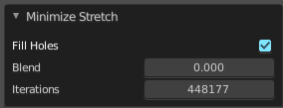

Last Operator Minimize Stretch

Fill Holes
Fill holes virtually fills holes before unwrapping to avoid overlappings and to preserve the geometry.

Blend
The Blend factor is the value between the original and the maximum minimized stretch.

Iterations
Number of iterations for the Minimize stretch algorithm.

Stitch
Stitch tries to union UV patches along the selected edges or vertices.
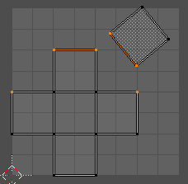
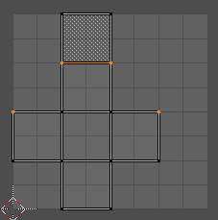

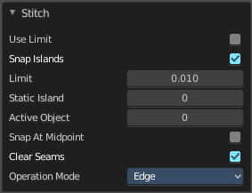
Last Operator Stitch
This last opeartor appears in the 3D view.

Use Limit
Just snap when the elements are below a given distance.

Snap Island
Snap the whole UV patch, or just the selected edge(s)/vertices

Limit
The limit distance for Use Limit.

Static Island
Adjustwhich island stays in place when stitching.

Active Object
Index of the active object.

Snap at Midpoint
Snap at the center point of the two elements instead the first to the last.

Clear Seams
Unmarks seams when stitching.

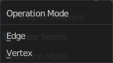
Operation Mode
The operation mode. Calculate with Edges or Vertices.

Mark Seam
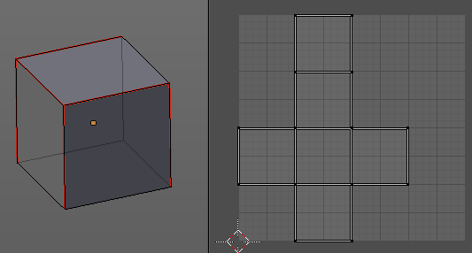
The unwrap algorithms Angle based and Conformal requires to have edges marked as seams. Think of it as a cutting pattern for a trouser for example. Such a trouser is also made of fabric patterns.
Same goes for the UV patches when you use Angle based or conformal unwrapping. You need to cut your mesh into parts and mark edges as seams, so that the algorithm knows where the seams are.
Mark seam marks the currently selected edge(s) as a seam. Seam edges will be displayed as red in the 3D viewport. But not in the UV Image Editor. The UV patches represents the seams.
You need to unwrap the mesh again when you want to apply changes by the new marked seams.

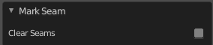
Last Operator Mark Seam

Clear
Clears the seam instead of marking it.

Clear Seam
Clear seam removes the seam from the currently selected edge(s) in the 3D view.

Seams from Islands
Unwrapping creates the UV geometry from the 3D object. You mark the seams, then you click at unwrap, and the UV mesh gets created.
Mark Seams from islands goes the other way around for marking seams. It creates the seams at the mesh object in the 3D view from the UV geometry in the UV Image Editor.
A use case is wheen you import meshes. Then you usually just have the UV patches in the UV Image editor. And when you want to modify the UV's further, then you need the seams at the mesh.

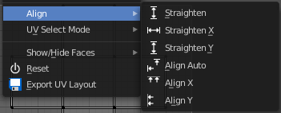
Align
Align the selected geometry. Affected are the vertices.

Straighten
Straightens the selected geometry in both directions, X and Y axis.

Straighten X
Straightens the selected geometry along the X axis.

Straighten Y
Straightens the selected geometry along the Y axis.

Align Auto
Aligns the selection. The align axis gets chosen from the selection itself. When it's higher than tall, then it aligns along the Y axis. When it's taller than high, then it aligns along the X axis.
The align point is the pivot of the selection.

Align X
Aligns the selection along the X axis. The align point is the pivot of the selection.

Align Y
Aligns the selection along the Y axis. The align point is the pivot of the selection.

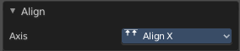
Last operator Align
The Last operator Align unions all the single straighten and align actions in one operator.

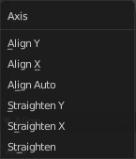
Axis
Lists the straighten and align methods again.

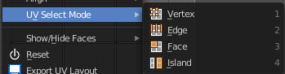
UV Select Mode
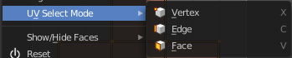
This is a double menu by design. It allows you to show and assign shortcuts to the UV Sync selection mode buttons in the header.

Show / Hide Faces
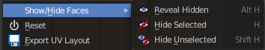
Show or hide faces. This happens in both, the 3D View and the UV editor.

Reveal Hidden
Makes all geometry visible again.

Hide Selected
Hides the selected geometry.

Hide Unselected
Hides the not selected geometry. The selected geometry stays visible.

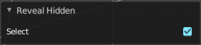
Last Operator Reveal Hidden / Hide Selected

Select
Define if the selected or the unselected elements gets hidden or revealed.

Reset
Resets the UV projection. Every single face gets fit into the UV space range of 0/1

Export UV Layout
Export the UV layout to an image, so that you can use it as a mask to build your texture in your favourite image editing software like Phothoshop. It will open a file dialog, where you can define further export settings down left.

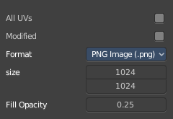
All UV's
Export all UV's, not just the visible ones.

Modified
Export UV's from the modified mesh.

Format
Choose the export format.

Size
Define the size of the image.

Fill Opacity
How opaque the wireframe lines are.

